**Visual Analysis**

Student Name

Institution Name

Course Name

Instructor Name

Date

**Visual Analysis**

**Visual Analysis of “*Celia Thaxter's Garden, Isles of Shoals, Maine, 1890*” by Childe Hassam**

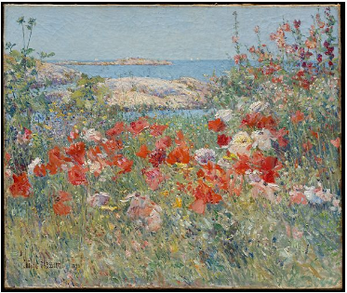

**Form**

The painting “Celia Thaxter's Garden, Isles of Shoals, Maine, 1890" by Childe Hassam is a stunning representation of the life and flora of the Isles of Shoals, Maine. The artist's choice of color and composition creates a compelling visual structure throughout the painting. Hassam captures the blue-gray sky and the water realistically and uses an impressionist style of painting with thick brushstrokes to capture the landscape. He also uses bright colors to depict the various plants and flowers in Celia Thaxter’s garden, which gives the painting a vibrant atmosphere.

**Function**

l idealism of the late 19th century. The painting was intended to capture the garden's beauty and evoke a sense of nostalgia for a simpler time. By depicting a lush and peaceful garden, the painting emphasizes the idea that nature is a source of beauty and peace. Hassam's painting can also be seen as a commentary on the rapidly changing landscape of the period, as industrialization began to transform the American landscape drastically.

**Content**

The painting “Celia Thaxter's Garden, Isles of Shoals, Maine, 1890" by Childe Hassam represents a tranquil and serene garden setting. The subject of the painting is a garden from the Isles of Shoals, off the coast of Maine (Hassam, 2022). This painting is a symbol of peace and beauty and serves as a reminder to appreciate nature in all its forms. The overall composition features an array of colors, including variations of blue, green, pink, and yellow, which come together to create an image that emanates calmness and peace. The painting also has a subtle symbolism of growth and renewal as the garden is blooming.

**Context**

Celia Thaxter’s Garden, Isles of Shoals, Maine, 1890, is an oil painting on canvas by Childe Hassam. The painting was created in the Impressionism style during the American Impressionism era, depicting a flower garden with a path leading to an enclosure. The painting was created while Hassam was in residence at the Isles of Shoals in 1890, and it reflects the artist's interest in nature and light. The artist captures the beauty of the garden and its surrounding countryside with a color palette of whites, blues, and purples. The painting gives off a sense of peace and tranquility and captures a moment in time that was later immortalized in this artwork (Hassam, 2022). The vibrant array of colors creates a lively atmosphere, with the predominant blues and purples creating a peaceful and serene feeling.

**References**

Hassam, C. (2022). *Celia Thaxter’s Garden, Isles of Shoals, Maine*. Metmuseum.org; The Metropolitan Museum of Art. <https://www.metmuseum.org/art/collection/search/14930>